
(Photo Credit: Henry Ruggeri)

Sennheiser Spectera Redefines RF Scalability on Back-to-Back Puscifer and A Perfect Circle Tours

From 10-Minute Swapping to Flyable Rig Flexibility, Monitor Engineer Chris Dwight Embraces Bidirectional Audio Multitasking

LOS ANGELES, August 26, 2026 – Managing the sonic landscapes for Maynard James Keenan’s twin avant-garde rock powerhouses — Puscifer and A Perfect Circle — demands an engineer who thrives in chaos. It’s a trait that monitor engineer Chris Dwight honed in the high-velocity club scene of Atlanta, Georgia, where immediate troubleshooting equated to survival. To bring sanity to a demanding schedule of back-to-back tours with both bands, Dwight and the technical crew deployed the new Sennheiser Spectera wideband bidirectional wireless system for in-ear monitoring, alongside the Digital 6000 series to completely redefine their stage architecture.

"When you’re transitioning from a two-month Puscifer tour straight into a run with A Perfect Circle, consistency and workflow efficiency become everything," Dwight says. "We weren't looking for change for the sake of change — we were looking for flexibility and long-term scalability."
While traditional wireless instrument and monitor layouts require navigating a fragmented grid of individual narrowband frequencies, Spectera completely revolutionizes the stage. Powered by Wireless Multichannel Audio Systems (WMAS) technology, Spectera replaces that crowded architecture with a single wideband RF channel, functioning as a unified, bidirectional ecosystem.

"Everything is unified, almost like a cell phone bouncing back and forth to find the best frequency in real time," says Dwight. "In the morning, I put up my scan antennas, look at what's available, and export it into SoundBase. Because Spectera condenses all those channels into a single 6 MHz bandwidth, it’s all done in 10 minutes. It’s crazy impressive just how quick it is!"

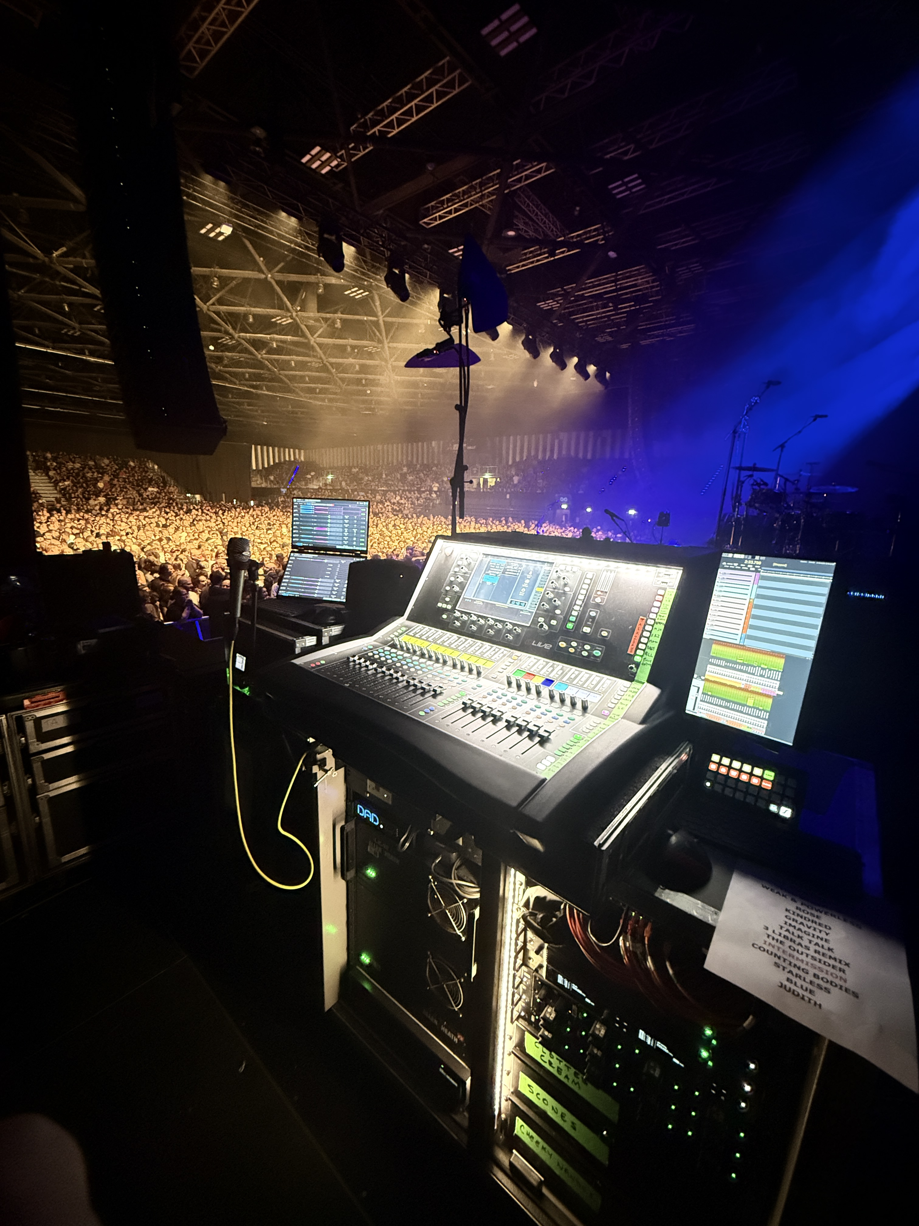
The Spectera base station backstage, providing unparalleled sound for audience members around the world.

That speed and bidirectional control proved to be a lifesaver during a high-stakes moment in a Salt Lake City arena. Right at showtime, local venue or security radios suddenly fired up, clouding the environment and causing digital breakup on a few artist packs. "Because of Spectera's bidirectional control, I was able to instantly find a new frequency within the software, deploy it, and it updated all the packs simultaneously within seconds while they were on stage," Dwight recalls.

On stage, Spectera’s SEK bodypacks handle both the artist's in-ear monitor mix and their wireless instrument transmitter simultaneously, cutting the band's hardware footprint in half. "My monitor rack is a fraction of the size it would normally be," says Dwight. "People probably assume the band is on stage wedges because there's no massive rack. I own a small digital console package that I can fly around the world. Just knowing I can throw a 1RU Spectera Base Station in a case, check it on an airplane, and have an entire band's wireless infrastructure with me is a game-changer."

From the monitor mixing station, Spectera’s web browser-based UI gave Dwight microscopic vision into the performance. "I can see actual data, even if someone's headphones are physically unplugged," he says. "Plus, two of the performers wear wardrobe where the packs are deeply hidden on their person. I was able to adjust their volume remotely from the software without messing with their outfits."

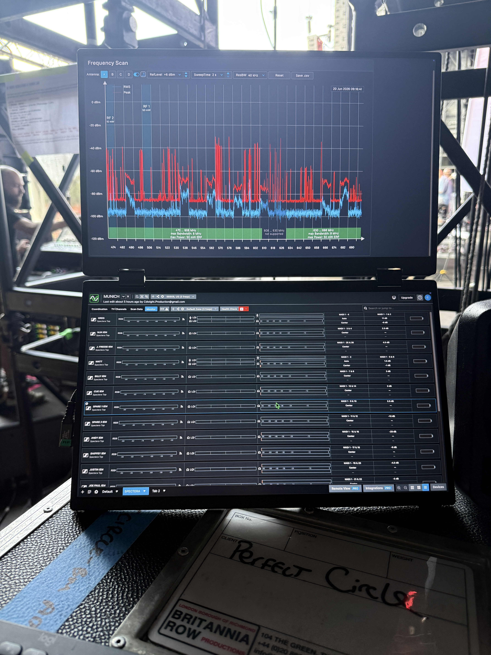
Spectera’s web UI allows users to find and deploy a new frequency to every connected bodypack in seconds, allowing seamless updates without interrupting the artist's performance.

This sweeping flexibility set the perfect stage for handling Maynard's distinct vocal requirements across both lineups. Because Maynard fronts both acts, keeping his vocal environment identical across both setups is paramount, which is why the team chose the Sennheiser Digital 6000 wireless system paired with the MM 435 capsule to anchor the vocal chain.

"They’re two very different sounding bands," Dwight explains. "The 6000s with the 435s for Maynard just worked. On the Puscifer stage, he’s moving all over the place — up on a ten-foot upstage riser, down past live amps and drums — and the mic gave us the clarity and articulation we needed without stage bleed. Moving into A Perfect Circle, he’ll be stationary right next to the drummer, so it’s all about familiarity. He walks into rehearsals, hears his vocal through that mic and those ears. Same console, same everything. It’s pure consistency."

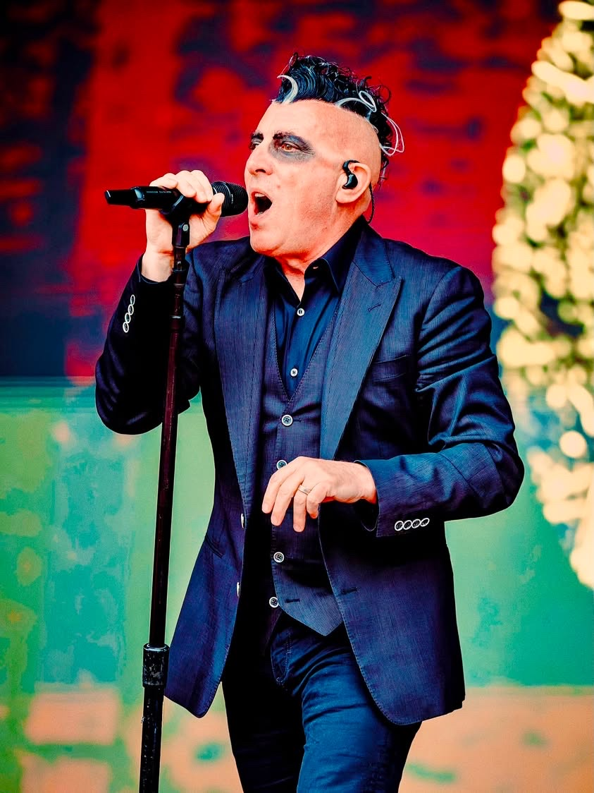
Maynard James Keenan relies on the MM 435 capsule with the Digital 6000 wireless system to deliver the clarity and consistency needed to move seamlessly between two very different live productions. (Photo Credit: Henry Ruggeri)

Beyond the vocal chain, maintaining that identical sonic standard extended to the backline, where the crew deployed Sennheiser wired microphones across the drum kits for both bands. To capture the complex, heavy percussion vital to both lineups while maintaining a clean stage aesthetic, Dwight relied on the Sennheiser MD 421 Kompakt.

"The MD 421 has always been a legendary drum mic, but on a busy stage, the classic size can sometimes get in the way of tight cymbal placements," Dwight notes. "The MD 421 Kompakt gives us that exact same iconic, punchy sound we expect on the toms, but in a remarkably sleek, rugged form factor. It keeps the drum setups incredibly low-profile and consistent from night to night, which is exactly what you need when you're jumping between two massive rock tours."

Dwight’s journey to the mixing board began unexpectedly years earlier in Atlantic Highlands, New Jersey. Tagging along for a "Take Your Kids to Work Day," a surprise plumbing call landed a young Dwight inside Bruce Springsteen's home studio during a demo tracking session. "Watching them work, I was completely floored by the process of recording and mixing," Dwight smiles. "I went straight home, bought a four-track recorder, and became the guy who recorded all my friends' bands." That divine intervention sparked a career path that eventually built an impressive touring roster engineering for the likes of Remi Wolf, Cold War Kids, The Midnight, and Pinegrove.


Dwight’s career as a monitor engineer started with a chance encounter that has taken him all over the world with some of the biggest names in rock.

Ultimately, the true success of the technology is how completely it disappears when the lights go down. Whether taming the sprawling, theatrical chaos of a Puscifer set or locking into the heavy, hypnotic studio precision of A Perfect Circle, Spectera ensures the technology steps aside. By replacing traditional RF boundaries with a singular, wideband stream, Dwight hasn't just consolidated his gear — he has ensured that Maynard's distinct sonic worlds remain entirely uninterrupted, leaving nothing on stage but the pure, uncompressed current of the music.

"I understand that people might be hesitant because it forces you to look at wireless in a completely new way," Dwight reflects. "But wireless should be looked at in a new way. This is an incredibly solid, powerful, beautifully made piece of hardware. I plan to use it on every single tour I do from now on."
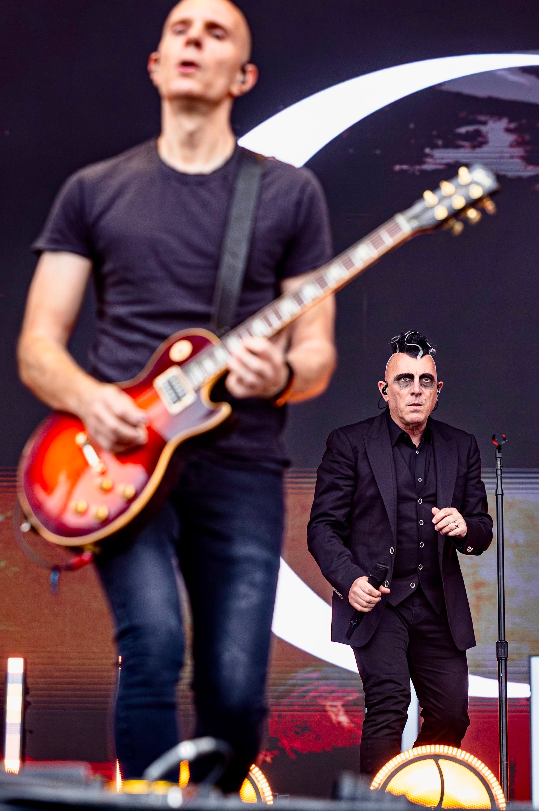
Spectera’s wireless capabilities provide pure, uncompressed audio that’s as pleasing to the fans as it is to the musicians on stage. (Photo Credit: Henry Ruggeri)

Dwight is currently on a European tour with A Perfect Circle and shares that, “Spectera has been a success for us thus far in the festival environment.” He looks forward to integrating the Spectera handhelds into both bands’ setup once they are available later this year.

The Spectera base station and accessories are available to order now, with the Spectera SKM handheld available for pre-order and shipping this fall. For more information visit http://www.sennheiser.com/spectera.

(Ends.)
###

About the Sennheiser brand
We live and breathe audio. We are driven by the passion to create audio solutions that make a difference. Building the future of audio and bringing remarkable sound experiences to our customers – this is what the Sennheiser brand has represented for more than 75 years. While professional audio solutions such as microphones, meeting solutions, streaming technologies and monitoring systems are part of the business of Sennheiser electronic GmbH & Co. KG, the business with consumer devices such as headphones, soundbars and speech-enhanced hearables is operated by Sonova Holding AG under the license of Sennheiser.

www.sennheiser.com
www.sennheiser-hearing.com

Local Press Contacts:
Daniella Kohan
daniella.kohan@sennheiser.com
+1 (860) 227-2235

InGear
Chloe Hildeman
chloe@ingearpr.com
+1 425-466-2264

